**Analysis of Crowdfunding Campaign Project**

By Ronda Hinz

**Conclusions**

Based upon the CrowdfundingBook data, the category/sub-category that achieved the most success, in terms of reaching their funding goal, is “theater” and “plays” respectively.

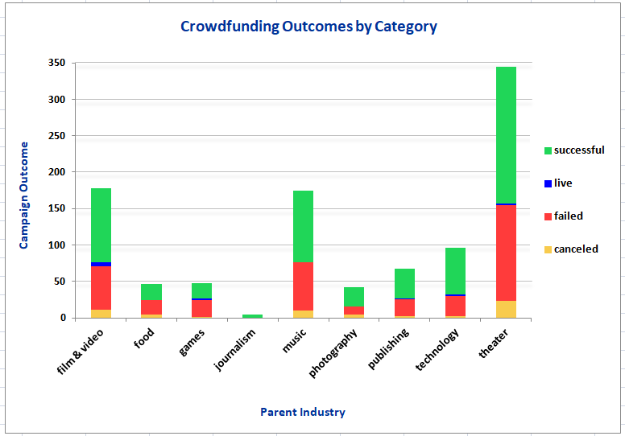

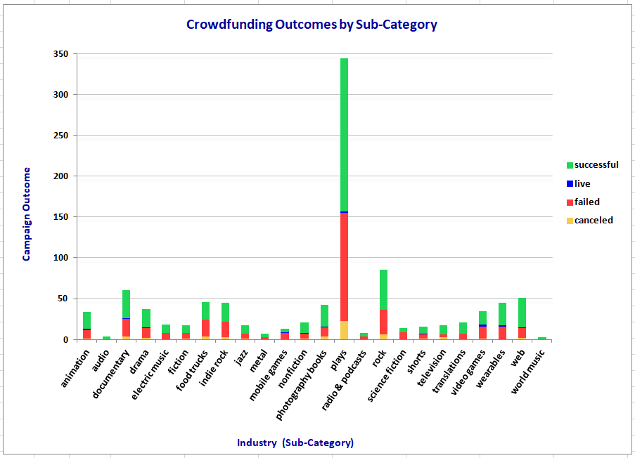

Campaigns launched during the months of May, June and July experienced the highest degree of success, especially when compared with campaigns that launched between the months of August and December. This could be linked to increased spending and tighter household budgets during the holiday shopping season.

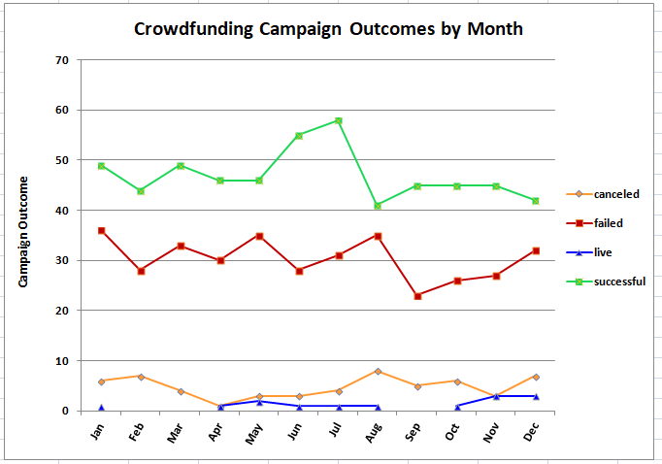

Finally, crowdfunding patrons have a desire to contribute to meaningful projects that could not be obtained without pledge money but are less interested in contributing to smaller projects that require less money to achieve. Campaigns with a funding goal of less than $10000 or more than $50000 are able to attain their goal about 50% of the time. This is in sharp contrast to campaign goals between $15000-$48000 with an average success rate of 70% and above.

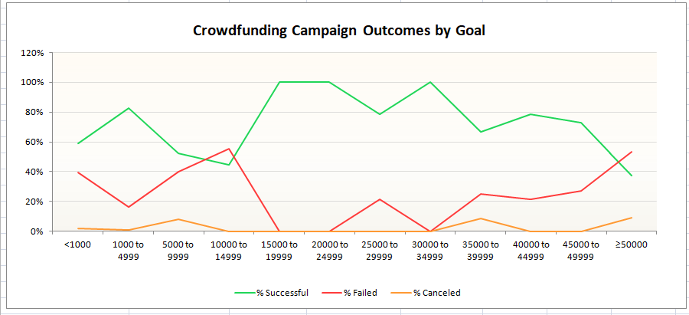

**Limitations**

This data set is unable to account for certain qualitative variables which could impact the outcomes of each campaign. These variables include marketing resources available to the fundraisers such as the number of hours dedicated to promotion and upfront financial investment needed to raise awareness.

It’s also important to consider that we are limited to evaluating crowdfunding campaigns from a total of seven countries which does not reflect the global investment in these categories.

**Recommendations for Further Exploration**

Additional insights could be gained through a comparison of **outcomes by the duration** of each campaign. Are campaigns that run longer more likely to achieve funding goals? Does pledge activity drop off over time or does it increase with greater awareness?

It would also be interesting to examine the **percentage** of successful campaigns versus failed campaigns for each category and sub-category. Evaluating percentages can be more revealing than evaluating totals for a number of reasons, especially when comparing data sets with extremes in range. For example, the sub-category for “plays” garnered a 54% success rate whereas “audio” has a 100% success rate. Does this confer more enthusiastic backing from audiophiles? It may be beneficial to take a closer look.

Similarly, there may be value in extracting the **average pledge** per backer for each category and sub-category for the same reasons as stated above.